Ferris® File-A-Wax® Blue

- Chemical Product and Company Identification
Product name: Ferris® File-A-Wax® Blue
- Hazards Identification
Classification of the substance or mixture: Not a hazardous substance or mixture.
GHS Label elements, including precautionary statements: Not a hazardous substance or mixture.
Hazards not otherwise classified (HNOC) or not covered by GHS: None.

- Composition/Information on Ingredients
Proprietary mixture of waxes.
No ingredients are hazardous according to OSHA criteria.
No components need to be disclosed according to the applicable regulations
- First Aid Measures
If inhaled
Move person into fresh air. If not breathing, give artificial respiration.
In case of skin contact
Wash off with soap and plenty of water.
In case of eye contact
Flush eyes with water as a precaution.
If swallowed
Never give anything by mouth to an unconscious person. Rinse mouth with water.
Most important symptoms and effects, both acute and delayed
The most important known symptoms and effects are described in the labelling and/or in section F.
Indication of any immediate medical attention and special treatment needed
No data available.
- Fire Fighting Measures
Extinguishing media
Suitable extinguishing media: Use water spray, alcohol-resistant foam, dry chemical or carbon dioxide.
Special hazards arising from the substance or mixture
Advice for firefighters
Wear self-contained breathing apparatus for firefighting if necessary.
Further information
No data available.
- Exposure Controls/Personal Protection cont.
Skin protection
Hand Protection
When handling product at elevated temperatures, use heat-resistant gloves. With product at ambient temperatures, use disposable nitrile, neoprene or butyl rubber gloves with repeated or prolonged use.
Body Protection
Prevent skin contact when handling heated material. Use insulated, heat resistant clothing such as apron or slicker suit.
Respiratory Protection
The need for respiratory protection is not anticipated under normal use conditions and with adequate ventilation. If elevated airborne concentrations above applicable workplace exposure levels are anticipated, a NIOSH-approved organic vapor respirator equipped with a dust/mist prefilter should be used.
Safety Stations
Make emergency eyewash stations, safety/quick-drench showers, and washing facilities available in work area.
General Hygienic Practices
Avoid breathing dust, vapor or mist. Avoid contamination of food, beverages, or smoking materials. Wash thoroughly after handling, and before eating, drinking or smoking. Remove contaminated clothing promptly and clean thoroughly before reuse.

- Physical and Chemical Properties
Information on basic physical and chemical properties

Appearance Blue solid
Odor Mild
Odor Threshold No data available
pH No data available
Melting Point No data available
Ring and Ball Softening Point 227°F
VOC Content 0
Initial boiling point & boiling range No data available
Flash Point(COC) 465°F (240°C)
Evaporation rate No data available
Flammability (solid, gas) No data available
Upper/lower flammability No data available
Vapor Pressure No data available
Vapor density No data available
Relative density (g/cc) 0.9 ± 0.05
Water Solubility Insoluble
Coefficient: n-octanol/ water No data available
Auto-ignition temperature No data available
Viscosity No data available
Explosive Properties None
Oxidizing Properties None
% Volatile 0

- Regulatory Information

US Federal Regulations
RCRA Hazardous Waste Number (40 CFR 261.33): Not listed
RCRA Hazardous Waste Classification (40 CFR 261): Not classified
CERCLA Hazardous Substance (40 CFR 302.4): Listed/unlisted specific per RCRA Sec. 3001
SARA 311/312 Codes: No hazard categories identified
SARA Toxic Chemical (40 CFR 372.65): No components were identified
TSCA Inventory Status: All ingredients listed on TSCA inventory requirements
State Regulations
This product is not known to contain any components for which the State of California has found to cause cancer, birth defects or other reproductive harm.

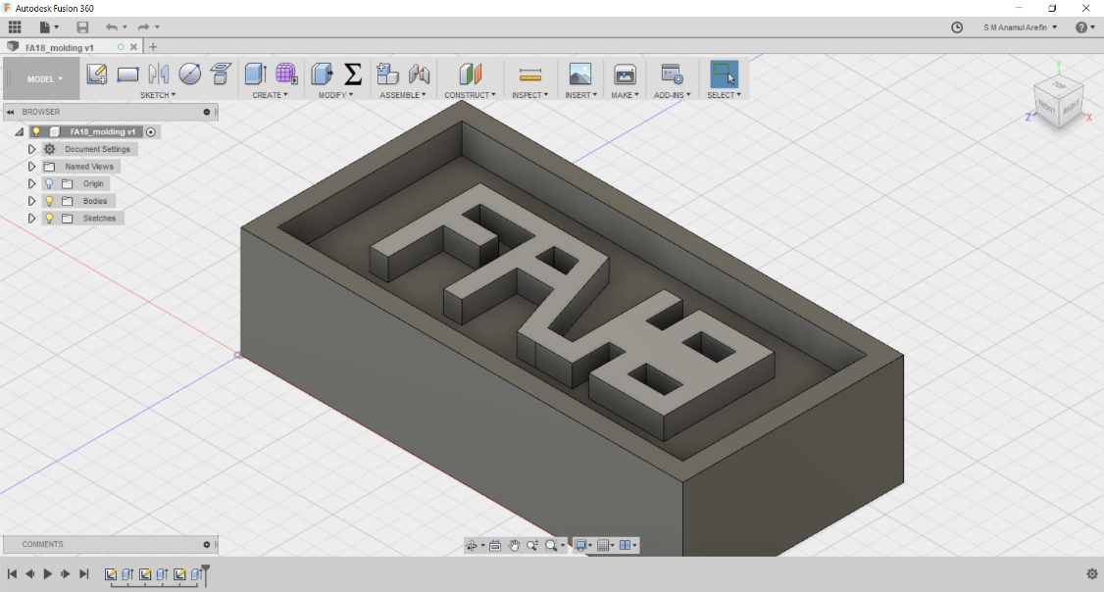
Group Part: I was tested was to milling and make mold by silicone rubber and final product with epoxy

