To install the necessary drivers & packages:.
sudo apt-get install flex byacc bison gcc libusb-dev avrdude
sudo apt-get install gcc-avr
sudo apt-get install avr-libc
sudo apt-get install libc6-dev

Program Arduino as ISP to program the ISP you created, then connect your ISP to the Arduino as seen below:
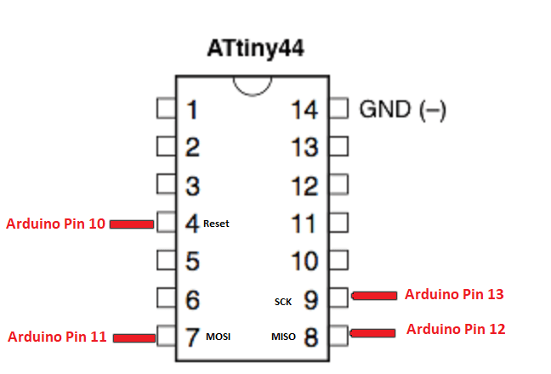

To download the firmware on the desktop:
cd ~/Desktop
wget http://academy.cba.mit.edu/classes/embedded_programming/firmware.zip
unzip firmware.zip

A makefile is a bunch of rules that explains how your board reacts based on certain prerequisites which affects the outcome of the program, called "target". In the end you'll have an executable file that dictates how your board operates.

Opene the MakeFile and comment this line
AVRDUDE = avrdude -c avrisp2 -P usb -p $(DEVICE) by adding a hashtag "#" and instead type
AVRDUDE = avrdude -c stk500v1 -P /dev/ttyACM0 -b19200 -p $(DEVICE)

sudo make fuse This links the executable file with the makefile.
sudo make program This compiles the program.

Lsusb To see if your ISP is being seen by the computer

